Integrating the Healthcare Enterprise



IHE Patient Care Coordination (PCC)

Technical Framework Supplement

Patient Centered Coordination Plan (PCCP)

Public Comment

Date: February 7th 2010
Author: Jon Hilton
Email: PCC@ihe.net.au
Foreword?
This is a supplement to the IHE PCC Technical Framework Revision 5.0

It is submitted for Public Comment between <June XX, 20XX and July XX, 20XX>.
Comments shall be submitted within that period to http://forums.rsna.org:
- Select the “IHE” forum
- Select <Domain Name> Technical Framework
- Select <20XX-20XX> Supplements for Public Comment
- Select <Supplement Name>
Please use the Public Comment Template provided there when starting your New Thread.

Details about IHE may be found at: www.ihe.net

Details about the IHE PCC Domain may be found at: http://www.ihe.net/Domains/index.cfm

Details about the structure of IHE Technical Frameworks and Supplements may be found at: http://www.ihe.net/About/process.cfm and http://www.ihe.net/profiles/index.cfm

The current version of the IHE <Domain Name> Technical Framework may be found at:. http://www.ihe.net/Technical_Framework/index.cfm

These ”boxed” instructions are for the author to indicate to the Volume Editor how to integrate the relevant section(s) into the overall Technical Framework
Replace Section X.X by the following:

Introduction
<provide a brief overview of the volumes/ sections of the Technical Framework that get changed/ added by this profile>
This supplement adds the Patient Centered Coordination Plan (PCCP) Profile to Volume I of the IHE PCC Technical Framework, and the Patient Centered Coordination Plan Content Module and related modules to Volume II.

Open Issues and Questions
Terminology
There is some potential for confusion over terminology – here is a list of important terms and a brief description of their intended meaning within the profile. One difficulty is the potential for confusion about whether a term refers to an actor for modelling purposes or a person who is undertaking activities in a description of intended workflow. The sense of the usage of these terms should be clear from context of usage. It would be more confusing to define alternative terms for the different senses of “Care Coordinator” and “Care Provider” below. If contributors disagree with this, I suggest they recommend alternative terms and split them out in the table below.

Care Coordinator | For modelling - Actor responsible for creating and editing (maintaining) a Coordination Plan.  For understanding workflow – the person who develops, deploys and monitors a plan for coordinating care.
Care Provider | For modelling - Actor responsible for providing Task Reports in response to notification of a Task to be performed.  For understanding workflow – a person who is a member of a care team associated with a plan, responsible for performing one or more tasks as documented in the plan. Responsible for reporting back to the care coordinator changes in the status of the task(s) they are responsible for.
Care Team | The collection of Care Providers mentioned in Plan Tasks associated with a Care Plan.
Coordination Plan | Document that contains a plan for coordinating care within an IHE Affinity Domain.
Plan Task | Element (document or document section) defining a task to be performed according to a Coordination Plan.
Task Status Report | Element (document or document section) that contains a field representing an update to the status of a Plan Task.
Role | A label that defines the specialty of the person required to perform a Plan Task.

I suggest first time readers of this draft now skip to X.1 Scope and Purpose on page 10. Familiarity with the draft itself will make the Open and Closed issues which appear in this section of the document much clearer.
Modelling Tasks and Coordination plans
A Plan Task document could be used to define the detail of individual tasks within a Coordination Plan. Tasks are a natural unit supporting the management of care, especially when managing issues of referral disposition, etc. Having Plan Task as a separate document will be useful in supporting referral workflow in the context of planned care. However, there are disadvantages to this. Detailed CDA modelling will be done with assistance from other members of the PCC Tech Working group who have expertise in this area.
The current profile documentation is written from a viewpoint of three “elements” used to support workflow – Coordination Plan, Plan Task and Task Status Report. Further work will be required to finalise the detailed modelling of these elements in CDA/XDS.
Using XDS Metadata (eventCodeList) to indicate Plan Task status in response documents
When a care team member takes action on a Plan Task, they will be required to register a Task Report document (see definition below). This will be required to reference the Plan Task that it relates to and will also contain a reference to documents created by the care team member that may contain arbitrary content governed by other IHE profiles. In addition to this, it would be desirable to use XDS Metadata to identify basic outcome information (a list of statuses, needing further development, but representing "Task on track (Green)", “Task needs attention from the care coordinator (Red)”, “Task needs attention from the care team member (Amber)”, etc. This list will no doubt be the focus of much discussion in future.
There is an existing metadata element – eventCodeList – that is used for this purpose. When a Task Report document is registered an appropriate entry must be added to eventCodeList in the metadata for that document.
There is a constraint on eventCodeList in the IHE PCC Technical Framework Vol 2.0 - page 27, 4.1.2.3.1.1 that abstracts important content from a document into XDS metadata in the eventCodeList.
The PCC Technical Framework appears to require a document - on page 23 in the table we have:
eventCodeList, | O, | CADT, | These values express a collection of keywords that may be relevant to the consumer of the documents in the registry. They may come from anywhere in the CDA document,according to its purpose.
We will use a similar approach, but need to agree on the document content and code list for the Task Report document.
Using Folders
It may be desirable to use folders to group Coordination Plan, Plan Task and Task Report documents.
The Document-based Referral Request (DRR) provides a useful context to folder and document requirements. Detail is specified in the PCC XDS-MS profile.
No work has been done to include reference to this in the profile.
Provider Directories, roles
There needs to be harmonisation between roles as defined relating to Plan Tasks, and work on provider directories. Coordination plan content needs to be harmonised with data model for services, roles, etc.
Value sets
Several value sets will be needed to support implementation of this profile. Identified so far are:
Role – this is a
CDA Modelling, PPOC, consistency of support for workflow, harmonisation
To date, no detailed modelling of the concepts in this profile into a CDA document set has been completed. There is a concern about overlap with developments underway in the IHI Committees. The current draft profile therefore present a high level modelling view of the proposed approach to facilitate further discussion regarding the best way to model the concepts in a way that is consistent with the overall approach to supporting collaborative workflows within IHE.
The Patient Centred Care Coordination plan should be harmonised with the IHE PPOC profile development, and work underway in the HL7 Community Based Collaborative Care group and the HL7 Patient Care working group.
There has been much discussion about the use of the PPOC document to hold the Coordination Plan content. An initial investigation shows that this should be feasible. We will need to pay attention to semantics and document a clear and comprehensive set of constraints and guidelines relating to the use of the PPOC document to ensure that the requirements for coordination outlined in this profile are covered. There are some differences in terminology that would also need to be taken into account.
There are subtle but important differences in the semantic content of the plans that will need to be addressed – PCCP treats Tasks as self contained entities, with a clear outcome associated with each task. Tasks are organised within Goals, but Goals are not the main focus of tracking – Tasks are. The intention here is to allow distribution of work to a care team, and for members of the team to be able to act independently (but in a cooperative and coordinated fashion) and to submit trusted reports on progress against their tasks. The aim is to provide efficient support for the Care Coordinator, allowing them to quickly identify which Tasks are not on track so that they can focus their attention on those tasks, modifying the Coordination Plan as required.
PPOC has two entities that relate to achieve a similar result, “Expected Outcomes” and “Orders”. This is a subtle but significant semantic difference that should be discussed and both profiles clarified. The PPOC relates expected outcomes to goals, and the tracking of the plan is then a matter of re-assessing progress against the desired outcomes (goals), and modifying the plan, either by changing the expected outcomes (because they are no longer realistic, or have been achieved, to pick some possible examples) or by changing the orders (for instance, to provide more intensive intervention in order to achieve a desired outcome).
The difference between these approaches is not irreconcilable, but there is quite a bit of work required to do so. The editor of the PCCP profile is willing to try, but will not be able to achieve this without cooperation and assistance.
There is a need for a Task Report document to assist with the distributed approach recommended in the PCCP. Encounters relating to Tasks in a Coordination Plan could have multiple documents associated with them. Having a separate Task Report document will simplify the tracking of task status, and avoid the need to scan and parse multiple documents to find the required information.

Existing PCC documents will be reviewed for conformance with user and business requirements and may need to be modified.
Need to ensure that the workflow support outlined is consistent with DRR, XDR, XDS and XDS-MS.

Acceptable Use Considerations

Acceptable use of data policies vary widely across the world. Suggest we treat this with great care and leave as much as possible to implementation.

The privacy level is set to determine access to the Coordination Plan document – options may include “general”, “limited to the care team”, “not available” unless authorized by the care manager. Need to reference existing IHE security model.

Document management and security

Audit trail, audit, authentication, version control, accessibility need to be managed by an appropriate infrastructure. It is believed that XDS.b and associated profiles are sufficient.

Provider and Service Directories, Referral Templates

Currently these are generally managed internally by the care manager. However this requires considerable effort by service providers to update every different care management system. Ideally the directories would be provided as independent services within a community. Such “service directory” actors could be added to support care coordination, at a later date.

Goals, tasks, dependencies

The role of goals and tasks should be clarified. What is clear and agreed is that Plan Tasks are the core unit of the Coordination Plan for tracking related activities – that is referrals, encounters, etc. should be tracked against tasks. Less well defined (and possibly out of scope for this profile) is the definition of goals including data items associated with them and their relationship with tasks.

What is agreed is that users should be presented with a view of the Coordination Plan that includes Goals. This leads to a question on the optimum data model – specifically, should the Coordination Plan contain a list of goals, and the Plan Tasks reference the goal or goals that they relate to?

Specific questions include:

Should a task be allowed without an associated goal?

Can a task be associated with more than one goal?

Should the goal description be coded as has been mandated for tasks?

Should a goal be required to have a target associated with it?

Should we require that goals meet some criteria such as being Specific, Measurable, Achievable, Realistic and Time-constrained (SMART)?

There was discussion of allowing for dependencies between tasks, although it was agreed that this was best left in the implementation domain – at least for now.

Is there anything else we can learn from the large body of knowledge relating to project management? Are there relevant standards that could be referenced or applied? In particular, the knowledge relating to the relevance and usefulness of management plans in various circumstances should be noted and applied.

Review

Is there a need to explicitly associate a review schedule with a Coordination Plan or should review tasks be included in the Coordination Plan? If the latter, should a review Plan Task be a mandatory component of a Coordination Plan?

Managing associations between Coordination Plan and tasks

Plan Tasks will be separate documents in the XDS Registry/Repository linked to the Coordination Plan. Other events will be recorded as separate documents which may be accessible and linked to the Plan Tasks. The Coordination Plan, Plan Tasks and any associated documents would constitute a document set.

An issue to be considered is the workflow where a Coordination Plan associated with events is changed or deleted under XDS document control, what happens to the associations? Proposed solution is that references are “copied forward” to the new version of a Coordination Plan that is modified. Superseded Coordination Plans are available for reference but are no longer actively monitored and therefore relationships will be static and could be archived as a whole. The process of managing submission sets in XDS will need to be reviewed in the light of these requirements.

Publish/subscribe: Notifications (e.g. of encounter, of changes to the Coordination Plan) may use DSUB. This would allow the care coordinator or individuals care providers to subscribe to new or updated documents (all or specific document types) being registered within an affinity domain.

Closed Issues
Name of profile
While care coordination often applies in chronic conditions, the methods are equally applicable for short term acute conditions, especially when managing a transition from acute to primary care for follow-up. Should the name be Care Coordination Workflow?
Tasks and actors
There is a view that when creating a Coordination Plan there is a need to assign a task to a role rather than an actor such as a service or individual. If this is included as a requirement it would complicate the relationship between Plan Tasks and referrals.
Task Outcome document
A third document type -“Task Report” - has been added to the profile.

Appointment schedule profile for future development

As appointments are scheduled for care events, these could be notified to the care manager and an appointment document created and stored in the repository. This would allow the patient via a PHR or other service to have visibility of all appointments and be subject of reminders based on this data. The care manager would be able to track appointment status (complete/DNA etc) from the appointment status notifications. While this is desirable, it is out of scope for current profile development, as inter-enterprise scheduling (appointment) workflow is not yet developed within IHE. Such enhancements may be expected to be future activities.
Referrals
It is expected that referral workflow and document content will be defined by relevant IHE profiles, with additional content added to meet specific requirements.
As IHE profiles define reusable components, which can be combined to create locally appropriate architectures, some implementations may not find it necessary to create referral documents at all if it can be assumed that all actors can access the Coordination Plan and associated task documents and receive a notification using Notification of Document Availability (NAV). A referral document can be created where there is a request for service involving identified actors because that is a better match for current practice. This makes even more sense if the medical history is available through the Care Management (CM) Supplement.

Multiple referrals

There may need to be consideration for multiple referrals relating to one Task – e.g. regular “renewals” of referrals required by fund holders. It will be critical to ensure that such re-referrals can be managed to support tracking of care events back to the initial referral.
Care Manager, care provision events in CM profile
The IHE Care Management (CM) profile describes a Guideline Manager actor supporting the distribution of guidelines in a standard format (see p. 25). A Care Manager actor is responsible for supporting the management of the care for patients with respect to a specific health condition (p38). The profile refers to care provision events. Are care provision events our tasks?
We have a Care Coordinator – responsible for coordinating care according to a plan – so as far as I can see there is no conflict here. There are many models of care. We should not be restricted to following existing mdels of care as embodied in existing profiles. We are proposing a model of care based on coordination of multiple care providers according to a coordination plan.
Care provision events are not tasks - many “care provision events” may be associated with a task. Care provision events are one potential subject for a Task Status Report – that is a Task Status Report may be reflecting the outcome of a care provision event. Other triggers and sources of data may be: activity by the patient (self care), results of orders (e.g. a pathology test result)
As an aside, I envisage a task something like “Check HbA1c within normal range every three months” would have a series of Task Status Reports associated with the task – reflecting status of that task such as “Test ordered”, “Result 6.8 (normal range)” – and these would be expected to appear every three months for the life of the plan.

TABLE OF CONTENTS

Volume 1 – Profiles 4
1.1.5 Copyright Permissions 4
2.5 Dependencies of the PCC Integration Profiles 4
2.7 History of Annual Changes 4
X <Profile Name Content/Integration> Profile 4
X.1 Scope and Purpose 4
X.2 Use Cases 4
X.3 Actors/ Transactions 5
X.4 Options 6
X.5 Groupings 6
X.6 Security Considerations 6
X.7 Requirements of Actors 6
X.8 Content Modules 7
X.9 Process Flow 7
<Appendix A> Actor Summary Definitions 8
<Appendix B> Transaction Summary Definitions 8
Glossary 9
Volume 2 – Transactions and Content Modules 9
3.0 IHE Transactions 9
3.Y <Transaction Name> 9
3.Y.1 Scope 9
3.Y.2 Use Case Roles 9
3.Y.3 Referenced Standard 10
3.Y.4 Interaction Diagram 10
3.Y.4.1 <Message_1 Name> 10
3.Y.4.1.1 Trigger Events 10
3.Y.4.1.2 Message Semantics 10
3.Y.4.1.3 Expected Actions 10
3.Y.4.2 <Message_2 Name> 11
3.Y.4.2.1 Trigger Events 11
3.Y.4.2.2 Message Semantics 11
3.Y.4.2.3 Expected Actions 11
3.Y.5 Security Considerations 11
3.Y.5.1 Security Audit Considerations 11
3.Y.5.1.(z) Actor Specific Security Considerations 11
6.0 PCC Content Modules 11
6.2 Folder Content Modules 11
6.2.Y <Folder Specification Name> 11
6.3 HL7 Version 3.0 Content Modules 12
6.3.1 CDA Document Content Modules 12
6.3.1.A <Document Content Module Specification Name> 12
6.3.2 CDA Header Content Modules 12
6.3.2.B <Header Content Module Specification Name> 12
6.3.3 CDA Section Content Modules 12
6.3.3.C <Section Content Module Specification Name> 12
6.3.4 CDA Entry Content Modules 12
6.3.4.D <Entry Content Module Specification Name> 12
6.5 PCC Value Sets 13
6.5.A <Value Set Name> 13
<Appendix letter> Appendix_Name 13

Volume 1 – Profiles
Add the following to section 1.1.5
1.1.5 Copyright Permissions

Add the following to section 2.5
2.5 Dependencies of the PCC Integration Profiles
<Profile Name> | <?> | <?> | <->

Add the following to section 2.7
2.7 History of Annual Changes

Add Section X
X PCCP Profile

The profile defines structured Coordination Plan, Plan Task and Task Report elements that can be associated with other elements relating to clinical encounter events. <note – at this stage, these are not defined as CDA documents> It defines how these elements can be linked, labelled and shared in order to support coordination of care across organizational and system boundaries amongst a care team that use a common XDS registry and operate within an Affinity Domain. This profile does not specify a care planning architecture, rather identifies IHE profile components that may be used in particular circumstances to support care coordination according to a coordination plan within an Affinity Domain.

X.1 Scope and Purpose
The Clinical Problem
An increasing number of people are suffering and dying needlessly from diseases such as obesity, diabetes, heart disease and asthma. Five chronic diseases—heart disease, cancer, stroke, chronic obstructive pulmonary disease, and diabetes—are responsible for the majority of deaths by disease worldwide. In addition to the tremendous human cost, chronic diseases exact an enormous financial toll on health care resources and strain public health departments and finances.
The effective treatment of chronic illness is characterized by productive interactions among involved patients, their carers, and a prepared team of healthcare providers. The Wagner Chronic Care Model is now widely viewed as providing a comprehensive best-practice model for this type of care. The goal of the model is to deliver care that is safe, effective, timely, patient-centered, efficient and equitable.
At the level of clinical practice, four components of the Wagner Chronic Care Model influence the ability to deliver effective chronic illness care. These are: self-management support; delivery system design; decision support; and clinical information systems.
Although the Wagner Model focuses specifically on Chronic Care, the principles of collaborative Chronic Care Coordination workflow should be equally applicable in supporting planned transition between different areas of health care, such as acute to primary care, aged care to acute, etc.

CDM Storyboard
Bob Glucose, a patient, is diagnosed with type II diabetes by his doctor, Dr. Planner. Dr. Planner creates a coordination plan in consultation with Bob, using best practice guidelines to inform the plan.
The content of the coordination plan includes a schedule of tasks that are to be performed by the patient, by the doctor and by other health care providers (the care team.) In Bob’s case the care team consists of a diabetes educator, a podiatrist, an optician, a pharmacist and a psychologist. Encounters with the care team are scheduled in the plan with indicated dates. Dr Planner submits a copy of the coordination plan in a shared registry/repository and notifies the care team of the new coordination plan. Dr. Planner gives Bob a copy of the coordination plan and asks him to make appointments with the providers identified in the plan.
Each member of the care team, on receiving notification, acknowledges receipt of the notification. When Bob arranges an appointment, each member submits a simple “task report” document in a shared repository that indicates status of the relevant task in the plan. As Bob visits the care team members, each member submits another instance of the same simple document indicating the updated status of the plan. They may also choose to submit a record of encounter including any reports relating to the encounter in the shared repository.
Six months later, Bob visits Dr. Planner for a regular review. Dr. Planner is able to access the shared repository and can see documents relating to Bob’s visits to his care team. There is a record of assessment, a diagram and a task report from the podiatrist. The task report indicates that the review task for podiatry is on track. There is an assessment and a task report from the diabetes educator indicating that there is an issue warranting further attention. There is no task report from the optician. Dr. Planner finds the assessment from the diabetes educator in the repository, counsels Bob on the issues flagged by the diabetes educator. He also asks Bob if he has visited the Optician, and Bob confirms that there was no appointment made. Dr Planner counsels Bob on the risks of retinopathy and advises him to visit the optician for a check as soon as possible.

Potential to support broader care coordination workflows
This profile focuses on support for planned care centred on the patient. This work originated from work in chronic disease management, but it is intended to be used in other appropriate circumstances, such as transition from acute to primary care for follow-up. A key element is the need to support coordination of care involving a care team, a designated set of actors that may include health providers as well as the patient and carers.
The Coordination Plan is not intended to replace other approaches to clinical care support, such as the clinical care plans described in the Patient Plan of Care (PPOC) profile. The Coordination Plan is intended to be used in circumstances where care is to be provided by a team of providers who are not guaranteed to have access to the same clinical management IT support system to support coordination of their activities. This is generally the case in chronic disease management, where care teams are often geographically dispersed and have substantially different information requirements, and thus different information systems.
The Coordination Plan and any associated documents should be seen as a component of a shared record that supports the management of some aspect of a patient’s care that would benefit from a planned approach and team based care. The collection of documents relating directly to the coordination plan could be gathered in a folder to assist identifying the collection as a cohesive unit of clinical information. It should sit comfortably alongside other clinical content, such as Patient Plan of Care documents, discharge summaries, test results and reports of all kinds. Some system developers may choose to support generation of a Coordination Plan from existing related plans that are currently maintained entirely within a single instance of a clinical information system. It would be equally valid for other developers to build stand alone systems that support the creation and monitoring of Coordination Plans.
It is entirely possible that a patient could have multiple concurrent Coordination Plans in operation at any given time. For instance, a patient with an existing Coordination Plan for diabetes could be hospitalised for treatment of a fracture, and, following acute intervention, could have another Coordination Plan to monitor and manage their rehabilitation with the support of a community based care team.

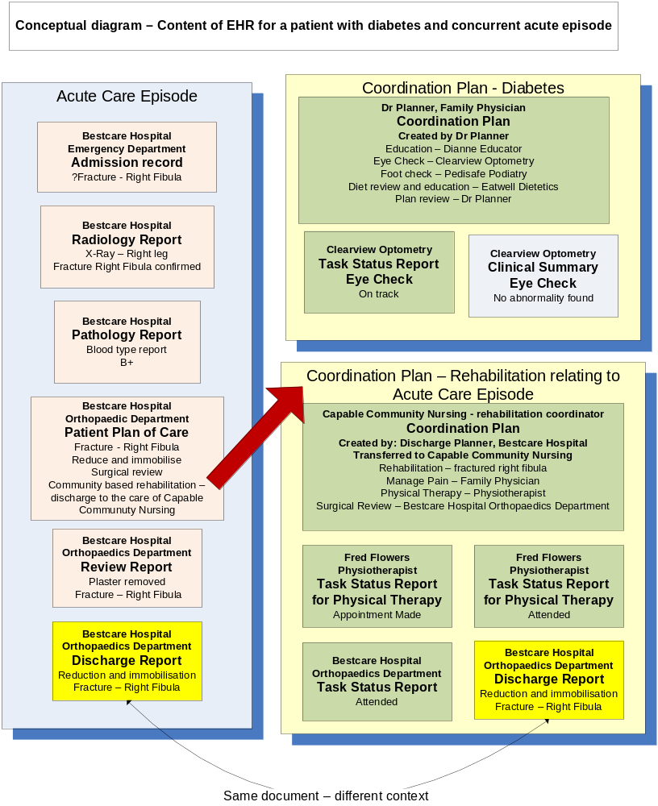
Figure X-1. Coordination Plan conceptual diagram – relationship with EHR

Planned care with assigned tasks – Coordination Plan and Plan Task
This profile uses an XDS repository along with three key elements, a Coordination Plan, Plan Task, and Task Status Report to support coordination of care across organisational and system boundaries. <note – these elements are discussed in context below as though they are separate documents registered in a repository – this may not be the final model agreed upon> These elements are deliberately minimal for ease of implementation, but are intended to align with specific care plan documents such as the Patient Plan of Care (PPOC) and the care plan under development in the HL-7 Patient Care working group.
The Coordination Plan is central to the profile, and contains structured data that supports management of a care coordination workflow within the sending and receiving systems. It consists of a series of goals and tasks with other information required to support scheduling and management of care.

Patient: Mr Bob Glucose Gender Male DOB 11/6/1950 |  |  | Purpose of plan : manage depression and alcohol dependence
Goal | Task | Responsible party |  | How Often | Commence | End | Comment
Manage Depression | Assessment and report | Ms Jane Insight, Psychologist, Health life medical centre |  | 3 monthly | 24/1/2010
Alcohol abstention | Order referral to gastroenterologist for assessment of liver damage | Dr. Planner, GP, HealthLife Medical Centre. |  | Once | 12/1/2010
Alcohol abstention | Counselling | New Farm, Alcohol and Drug Counselling Servicer |  | 6 monthly | 24/1/2010
Table X.1- Simple Coordination Plan
While the goals are important to the care team and the patient, the tasks associated with those goals are significant activities in the ongoing management of care coordination. The status of each task can be tracked with some precision, as they are identified as occurring within a given timeframe and with an actor responsible for the performance of the task. Plan Tasks are therefore defined as documents that are linked to a Coordination Plan.
One actor is designated as the Care Coordinator and is the custodian of the Coordination Plan. A Coordination Plan can only have one Care Coordinator, designated at the time of creation. It should be possible to transfer control of and responsibility for a Coordination Plan to another Care Coordinator, providing there is only one owner of the Coordination Plan at any given time. A patient may have more than one Coordination Plan active and these different plans may have different Care Coordinators. The Coordination Plan and Plan Task documents are “static” in the sense that they can only be changed by the current document owner.
Workflow support for care coordination is supported by a number of transactions that relate documents, such as reports and notifications, with Plan Tasks and thus to the Coordination Plan and the patient.

Support for tracking the plan– Task Status Reports
Each time action is taken on a Plan Task (that is, a service is delivered) a Task Report document must be submitted by the Care Provider. The most recent Task Report registered for a Plan Task should represent the “current status” of the Plan Task. The collection of current status information for all the Plan Tasks should indicate the status of the overall Coordination Plan.
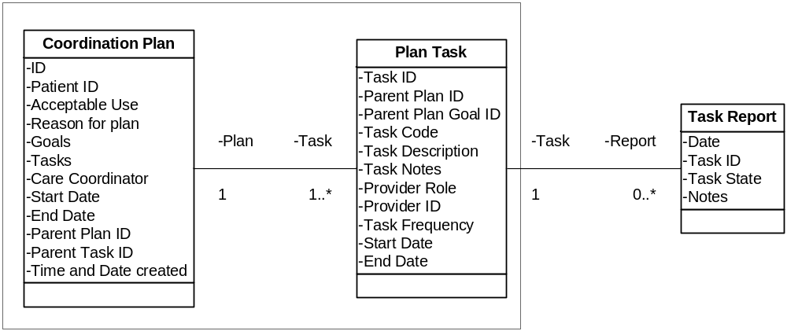
Figure X-1. Relationship between Plan, Task and Report
The status of a Coordination Plan can be established by accessing the XDS registry to identify the relevant documents. Metadata in the XDS registry can be used to make this process more efficient. The Task Report document(s) associated with a Plan Task allow the status of each task (and a history of status) to be quickly identified. The collection of
Referring to the simple example above, the existence in the XDS repository of a Task Report document about Mr Bob Glucose, authored by Ms Jane Insight, dated January 26th 2010 linked to the “Assessment and Report” Plan Task with an eventCode of “Plan Task On Track” in the metadata for the Task Report indicates that as at late January 2010, that task is “on track” and not due for any action. Similarly the absence in the XDS registry of a notification of attendance by Mr Glucose submitd by the New Farm Alcohol and Drug Counselling Service for Counselling on January 29^{th,} 2010 would indicate that that task is not on track. System developers can use the collection of information in the XDS repository to provide support for care coordinators and care team members in the coordination of care through their systems. This approach would also support development of sophisticated decision support systems designed to support care coordination.
Apart from using Query for Existing Data (QED) to retrieve the Coordination Plan, Plan Tasks and any reports relating to those documents, information systems will be able to query data repositories for clinical information on vital signs, problems, medications, immunizations, and diagnostic results, and Medical Summaries (MS), which defines the content and format of Discharge Summaries and Referral Notes. The Coordination Plan, Plan Tasks and Task Report elements would become another component of the medical record in the XDS Registry/Repository.
X.2 Use Cases
<One or more use cases that this profile addresses>
Create Coordination Plan
Pre-condition: The care manager has identified the need for a coordinated approach, the conditions to be managed and the relevant health services and providers allocated to a specific task. A patient record exists in a repository.
A Coordination Plan document is created along with associated Plan Tasks and submitd in the XDS repository.
Care Team
The initial “care team” is defined as the patient, the Care Coordinator, and the set of healthcare services/providers associated with the Coordination Plan assigned to one or more tasks in the plan. Note that the care team may change at any time.
Subordinate Coordination Plans
A Plan Task may be associated with a “subordinate” Coordination Plan, which would normally be created and managed by the provider responsible for that task. This plan will outline a series of tasks required to achieve the higher order task in the “superior” Coordination Plan.
Create Coordination Plan Submission Set
The Coordination Plan and Plan Tasks Documents will be accessible by the care team via an XD* transport mechanism. Care Manager is the Content Creator for the Coordination Plan and Plan Task Documents.
Notify Care Team Members of Plan and Plan Tasks
Preconditions: Existence of a Coordination Plan
For each task in the Coordination Plan assigned to an actor other than the Care Coordinator or the patient, a notification is sent to the care team member. Notification is mandatory and could be achieved in a number of ways:
- By Notifying care team members of the availability of a new Coordination Plan and Plan Tasks
- By creating and sending a referral.
Create Task Report
Preconditions: A Coordination Plan exists and the service provider generating the Task Report is responsible for the Plan Task that the report relates to.
An encounter Report will occur to address a task identified in the Coordination Plan.
Task Reports
The reported outcome of an encounter event will at a minimum be a Task Report. But it may include a number of documents created during the encounter event. For each encounter event, the service provider creates an encounter document with the minimum data set covering the date, , Coordination Plan ID, Task ID and Task state.
Other data associated with a care event should be provided if available. Examples could include Care Summaries, test results, or any other document that is consistent with an IHE profile and can be registered in an XDS Registry.
Task Reports indicate the state of the Plan Task to which they relate - “Task on Track”, “Task needs attention from the care coordinator”, “Task needs attention from the care team member”, ...(this list will need further consideration – see open items)
A Task Report is included in a document submission with other relevant documents and linked by an XDS association with the Plan Task. The Task and associated documents will be accessible by the care team via an XD* transport mechanism. The Service Provider is the Content Creator for the Task Report document.
Notification
NAV or DSUB can be used for notifications of any updates to any subordinate documents posted by the Care Team.
Review Coordination Plan and update task and related documents
From time to time the healthcare service provider (member of the care team) will provide notifications of key events such as care encounters, or generate other documents or reports such as appointment notifications, care event notifications, care event summaries. These are created by care team members, must reference the tasks that they are associated with, and made available to the care team via the document repository and notification processes. The data contained in these documents updates may be used in conjunction with the Coordination Plan to monitor the status of care.
The Care Coordinator may periodically review the Coordination Plan based on examination of documents associated with the Coordination Plan which include referral outcomes, medical (encounter) summaries, and other documents authored by care team members. The care manager may modify the original Coordination Plan. The care team will be notified of new documents relating to this patient.
X.3 Actors/ Transactions
<Actor/ Transaction diagram and Actor/ Transaction table. >
As for XDS-MS, it is expected that the transfers of care will occur in an environment where the care team is coordinated within a regional health information organisation that serves the information sharing needs of a community of care settings. A registry/repository-based infrastructure supported by the IHE Cross-Enterprise Document Sharing and other IHE Integration Profiles such as patient identification (PIX & PDQ), security and privacy (CT, ATNA, XUA), and notification of availability of documents (NAV) is used (See IHE IT Infrastructure Technical Framework, http://www.ihe.net/Technical_Framework/ ). The sharing or transmission of content or updates from one actor to the other is addressed by the use of appropriate IHE profiles described by section 3.7 Content Bindings with XDS, XDM and XDR found in the Patient Care Coordination Technical Framework.
There are three actors in this profile, a Care Coordinator, a Care Team Member and a Registry/Repository. Coordination Plans and associated Plan Tasks are generated by a Coordinator and they are to be to be consumed by a Care Team Member. The Care Coordinator must notify Care Team Members of the existence of a Coordination Plan and may optionally create a referral document and share that with the care team member. The sharing or transmission of content from one actor to the other is addressed by the appropriate use of IHE profiles, and is out of scope of this profile.

Figure X.3 0-1 Patient Centred Coordination Plan Actors and Transactions

Table X.1-1. Patient Centred Coordination Plan Integration Profile - Actors and Transactions
ctors | Transactions | Optionality | Section in Vol. 2
Care Manager | Query Registry | R | ITI TF-2: 3.16
Care Manager | Provide and Register Coordination Plan and Plan Task Document Set | R | ITI TF-2: 3.15  PCC PCCP <x.xx>
Care Manager | Provide and Register Task Report Document | R | ???
Care Team Member | Query Registry | R | ITI TF-2: 3.16
Care Team Member | Retrieve Coordination Plan and Plan Tasks Document Set | R (Note 1) | ITI TF-2: 3.15  PCC PCCP <x.xx>
Care Team Member | Provide and Register Task Report Document | R | ???
Document Registry/Repository | Provide and Register Document Set | R | ITI TF-2: 3.15
Document Registry/Repository | Register Document Set | R | ITI TF-2: 3.14
Document Registry/Repository | Retrieve Document | R | ITI TF-2: 3.17
Document Registry/Repository | Register Document Set | R | ITI TF-2: 3.14
Document Registry/Repository | Query Registry | R | ITI TF-2: 3.16

Note 1: The Actor shall support at least one of these options.

X.4 Options
<Table describing the options available for this integration profile and references to all sections that state requirements for compliance to the Option.>
Options that may be selected for this Profile are listed in the table X.2-1 along with the Actors to which they apply. Dependencies between options when applicable are specified in notes.
Table X.2-1 <Profile Name> - Actors and Options
Actor | Options | Vol & Section
Actor A | No options defined | - -
Actor F | No options defined | - -
Actor D/ Actor E | No options defined | - -
Actor D/ Actor E | No options defined | - -
Actor B (Actor C) | No options defined | - -
Actor B (Actor C) | No options defined | - -

X.5 Groupings

<Actors from other profiles, possibly in other domains, that this profile shall, may or should be grouped with.>

X.6 Security Considerations
<Description of the Profile specific security considerations. This should include the outcomes of a risk assessment. This likely will include profile groupings, and residual risks that need to be assigned to the product design, system administration, or policy.>
Affinity Domains will define their own policies for acceptable use. Access control may be used to determine access to the Coordination Plan document – this should reference the existing IHE security model.

Audit trail, audit, authentication, version control, accessibility need to be managed by an appropriate infrastructure. XDS.b and associated profiles are sufficient for this purpose.

X.7 Requirements of Actors
<Specific requirements for each Actor defined within this profile>

X.8 Content Modules
<Define which document content module(s) shall be used. Not all profiles will have content in this section.>
Note from Jon Hilton: These need to be worked up as an appropriate set of CDA documents. It may be that existing documents can be used, that there may not be a need for three separate documents.
Coordination Plan Document
The Coordination Plan contains structured data that supports management of care coordination workflow. This Coordination Plan dataset contains:
- Unique ID for the Coordination Plan
- A unique identifier for the patient who is the subject of the Coordination Plan
- Information to support Acceptable Use policy for this document
- Reason for plan (e.g. medical conditions covered by plan)
- Goals of the Coordination Plan (list of goals each with a goal ID for reference by Plan Task)
- IDs of one or more Tasks (further details below)
- Identity of the Care Coordinator
- Descriptor (codified) for the problem(s) addressed by this Coordination Plan
- Start date for Coordination
- End date for Coordination Plan (optional)
- References to a parent Coordination Plan and Plan Task (optional)
- Reference to Care Planning guidelines, if applicable (optional)
- Reference to instructions, patient education materials, if applicable (optional)
- Reference to other preexisting Coordination Plan and task (optional)
- Time stamp
Plan Task Document
Plan Tasks are documents that are linked to a Coordination Plan. Minimum data required for each Plan Task is:
- Unique identifier for each Task
- ID of parent Coordination Plan
- Descriptor (codified) for the task to be performed
- Notes or instructions relating to the task to be performed
- Role of provider performing the task
- Identification of the Provider responsible for performing the task, This provider may be the patient or a healthcare provider identified as an individual or as a service. The Coordination Plan may identify a role required to provide the service without identifying an individual or service.
- Frequency of task, e.g. 3 monthly, annually, etc., “ongoing” to indicate constant monitoring activities, “once” to indicate one-off task, “as required” to indicate that clinical judgment is to be used.
- Start date for task (date from which the task should be scheduled)
- End date for task (optional)
Task Report document
- Time and Date of the activity that led to the report
- Task ID that the report relates to
- Code for the state of the task indicted by this report
- Brief text note relating to the activity (optional)
The Coordination Plan, Plan Task and Task Report documents require globally unique identifiers and individual access control.

X.9 Process Flow
<Description of the process flow(s) and sequence diagram(s) covered by this profile in order to satisfy the use cases. This often will include a brief description of the use cases as well. If there are detailed behavioral rules that apply to a specific process flow or multiple process flows or descriptions then an appendix may be added as needed>
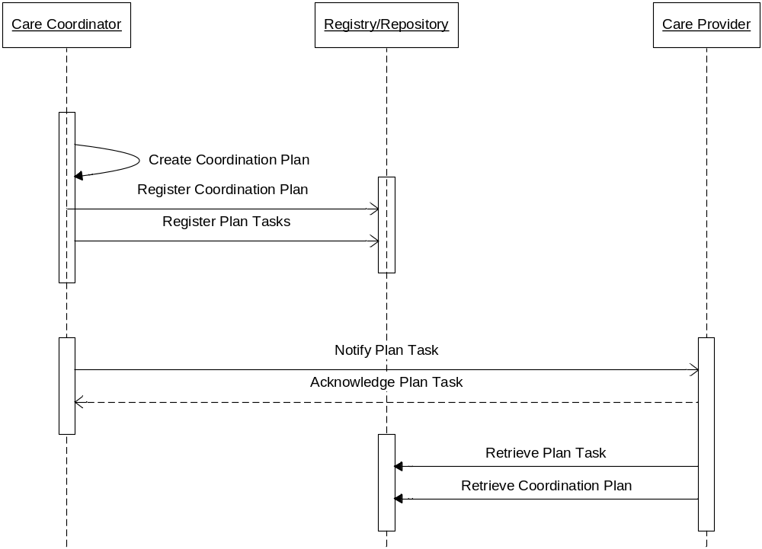
Figure X 9. 1 Create Coordination Plan

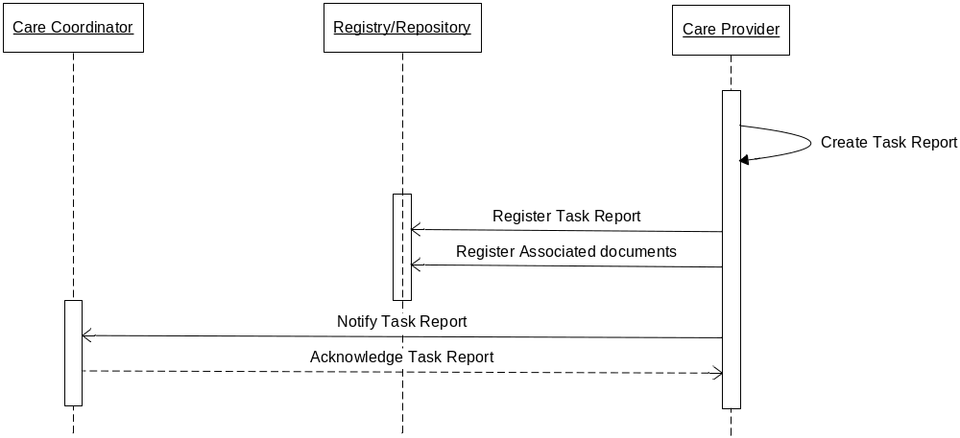
Figure X 9. 2 Create Task Report
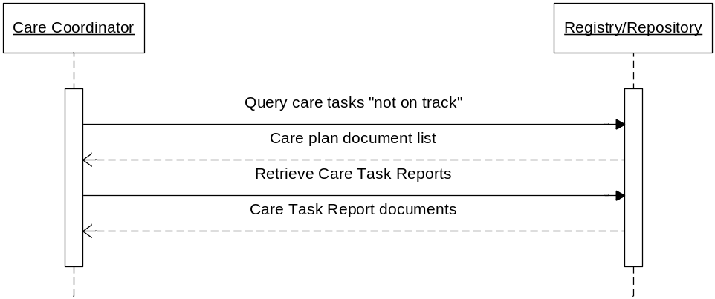
Figure X 9. 3 Review Coordination Plan

<Appendix A> Actor Summary Definitions
<add any actor definitions for new actors defined specifically for this profile>
Care Coordinator | Responsible for creating and editing (maintaining) Coordination Plans and associated Plan Tasks
Care Provider | Responsible for submitting Task Status Reports

<Appendix B> Transaction Summary Definitions
<add any transaction definitions for new transactions defined specifically for this profile>

Glossary
Add the following terms to the Glossary:
<any glossary additions associated with the profile draft go here>

Volume 2 – Transactions and Content Modules
<A PCC Profile will have sometimes have Transactions, will sometimes have Content Modules, and sometime may have both. Following are guidelines on the content needed in sections for both Transactions and Content Modules.>

3.0 IHE Transactions

Add section 3.Y
3.Y <Transaction Name>
<This section corresponds to Transaction Y of the IHE Technical Framework. Transaction Y is used by the <ABC> and <DEF> actors. This section may or may not be present depending on the issues the profile addresses.>

3.Y.1 Scope

3.Y.2 Use Case Roles
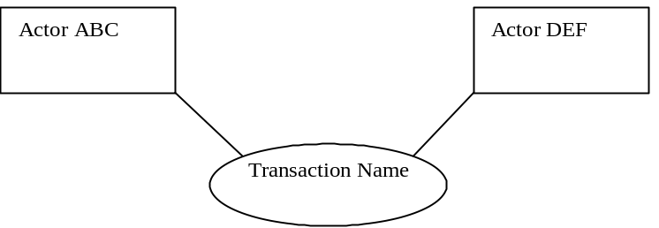

Actor:
Role:
Actor:
Role:
Actor:
Role: .

3.Y.3 Referenced Standard
<e.g., HL7 2.3.1 Chapters 2, 3>
<e.g. DICOM 2008 PS 3.3: A.35.8 X-Ray Radiation Dose SR IOD>

3.Y.4 Interaction Diagram
<the interaction diagram shows the detailed standards-based message exchange that makes up the IHE transaction>
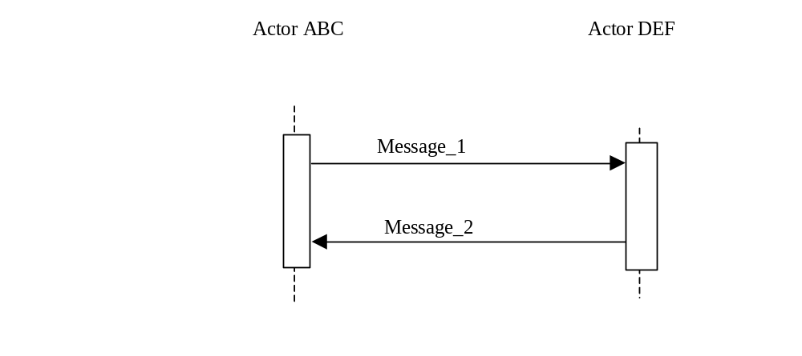
3.Y.4.1 <Message_1 Name>
<One or two sentence description of the first message of the above interaction diagram, typically relating the message to the relevant standard>

3.Y.4.1.1 Trigger Events
<description of the real world events that cause the initiation of the first message>

3.Y.4.1.2 Message Semantics
<detailed description of the meaning, structure and contents of the first message including any IHE specific clarifications of the message format, attributes, etc.>

3.Y.4.1.3 Expected Actions
<description of the actions expected to be taken as a result of sending or receiving this message>

3.Y.4.2 <Message_2 Name>
<One or two sentence description of the the next message in the above interaction diagram, typically relating the message to the relevant standard. Note, repeat this section as necessary based on the number of messages in the interaction diagram>

3.Y.4.2.1 Trigger Events
<description of the real world events that cause the initiation of the next message>

3.Y.4.2.2 Message Semantics
<detailed description of the meaning, structure and contents of the next message including any IHE specific clarifications of the message format, attributes, etc.>

3.Y.4.2.3 Expected Actions
<description of the actions expected to be taken as a result of sending or receiving this message>

3.Y.5 Security Considerations
<description of the transaction specific security consideration. Such as use of security profiles. >

3.Y.5.1 Security Audit Considerations
<This section should specifiy any specific ATNA security audit event that is associated with this transaction and requirements on the encoding of that audit event. >

3.Y.5.1.(z) Actor Specific Security Considerations
<This section should specifiy any specific security considerations on an Actor by Actor basis.>

6.0 PCC Content Modules

6.2 Folder Content Modules

Add section 6.2.Y
6.2.Y <Folder Specification Name>
<This section corresponds to Folder Specification Y of the IHE Technical Framework. Folders are typically used to manage content profiles. This section may or may not be present depending on the issues the profile addresses.>

6.3 HL7 Version 3.0 Content Modules

6.3.1 CDA Document Content Modules

Add section 6.3.1.A
6.3.1.A <Document Content Module Specification Name>
<This section corresponds to Document Content Module Specification A of the IHE Technical Framework. This section may or may not be present depending on the issues the profile addresses.>

6.3.2 CDA Header Content Modules
Add section 6.3.2.B
6.3.2.B <Header Content Module Specification Name>
<This section corresponds to Header Content Module Specification B of the IHE Technical Framework. This section may or may not be present depending on the issues the profile addresses.>

6.3.3 CDA Section Content Modules
Add section 6.3.3.C
6.3.3.C <Section Content Module Specification Name>
<This section corresponds to Section Content Module Specification C of the IHE Technical Framework. This section may or may not be present depending on the issues the profile addresses.>

6.3.4 CDA Entry Content Modules
Add section 6.3.4.D
6.3.4.D <Entry Content Module Specification Name>
<This section corresponds to Entry Content Module Specification D of the IHE Technical Framework. This section may or may not be present depending on the issues the profile addresses.>

6.5 PCC Value Sets
Add section 6.5.A
6.5.A <Value Set Name>
<This section corresponds to Value Set A of the IHE Technical Framework. This section may or may not be present depending on the issues the profile addresses.>
Provider Role
Core set may be defined but will be specific to Affinity Domain
Dietician
Diabetes Educator
Physiotherapist
Family Physician
Orthopaedic Surgeon
Community Nurse
Optometrist
...
Task Status Report Status Code
To be defined
<Appendix letter> Appendix_Name
<Detailed cross transaction relationships or mapping details are described in an appendix in Volume 2>

Wagner E, Austin B, Von Korff M. Organizing care for patients with chronic illness. Millbank Q 1996: 511-544.

